**Computer Network Lab – 02**

|  |  |
| --- | --- |
| **Muhammad Rehan** | **BSDSF22A001** |

1. **Managing a New Employee's Account**

* sudo useradd -m Alex
* sudo passwd Alex
* sudo groupadd develepors
* sudo usermod -aG develepors Alex
* cat /etc/passwd | grep Alex
* groups Alex
* cat /etc/passwd

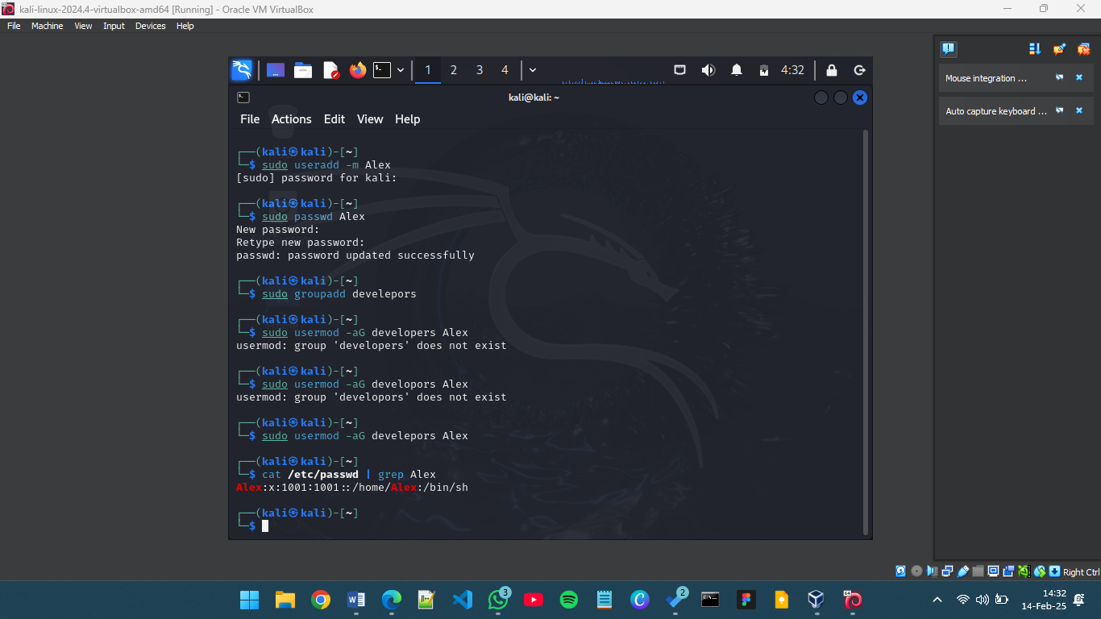

1. **Troubleshooting Network Issues**

* ifconfig
* sudo systemctl restart networking
* sudo netstat -tulnp
* sudo iptables -L

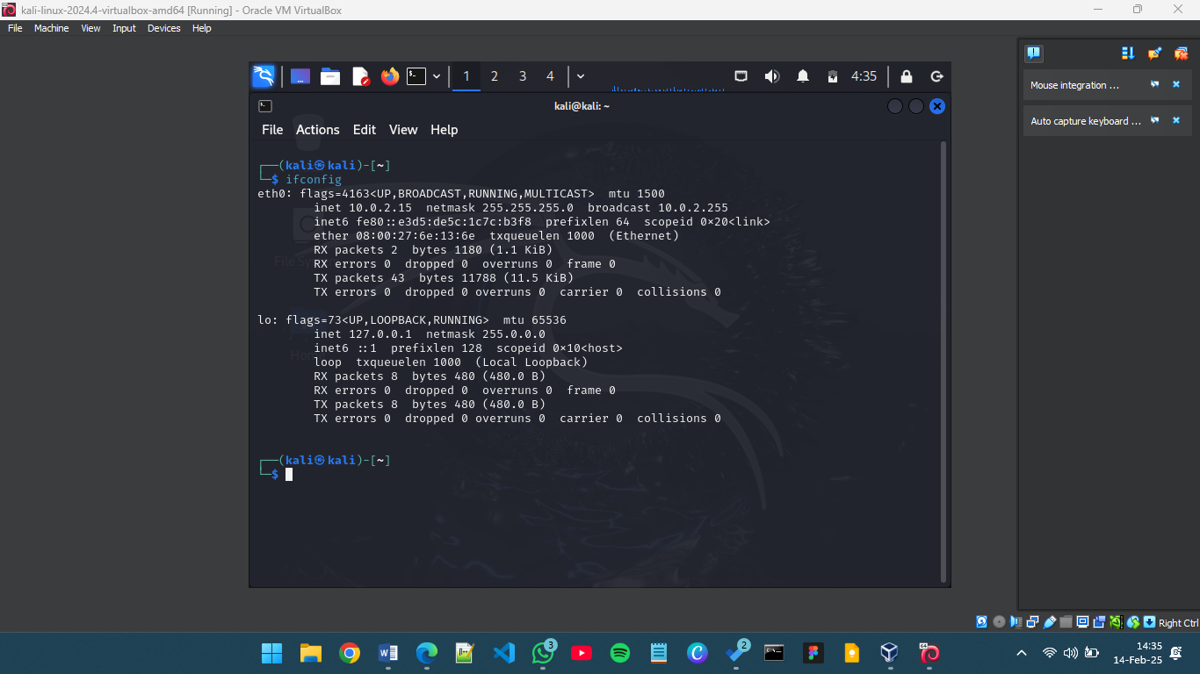

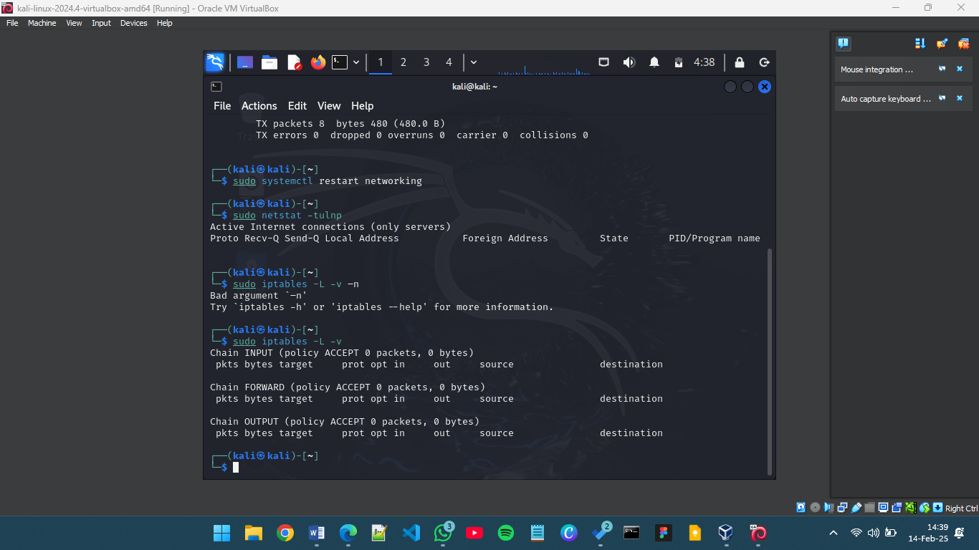

1. **Securing a User Account**

* sudo usermod -L Alex
* sudo find / -user Alex 2>/dev/null
* sudo gpasswd -d Alex develepors
* sudo userdel -r Alex
* cat /etc/passwd | grep Alex

